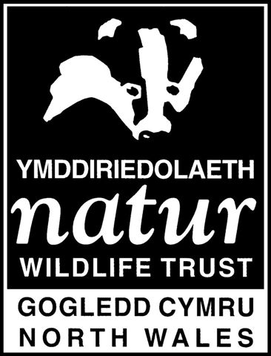
NORTH WALES WILDLIFE TRUST: RISK ASSESSMENT

Dormouse Nuthunt Surveys

Severity: 1 Negligible 2 Minor injuries requiring first aid only 3 Major injuries requiring hospitalisation 4 Fatality

Probability: 1 Improbable 2 Possible 3 Has occurred at least once/ highly possible 4 Regular / frequent

No. | Hazard | Risk | Severity/  Probability | Action
1 | Cuts, bites and stings | Injury | 2/2 | Be aware of potential hazards. Inform leader if you have any allergies. Wear appropriate clothing.
2 | Falling trees in strong wind | Injury / Death | 4/1 | Do not work in strong winds (Force 4 or above).
3 | Uneven terrain | Sprains, broken bones | 3/2 | Be aware of hazards. Tread carefully.
4 | Whip lash from branches | Eye injury | 3/2 | Be aware of those behind you. Be vigilant.
5 | Hidden litter e.g. bottles | Injury | 2/2 | Ensure area is free of litter before surveying.
6 | Slippery ground | Sprains, broken bones | 3/2 | Be aware of hazards. Wear suitable footwear. Do not survey in very wet weather.
7 | Weather | Hypothermia  Death / Injury from Lightning  Heat stroke | 4/1 | Wear appropriate clothing. Check weather forecast. Do not survey in very wet weather. Do not survey in thunderstorms. Be prepared for hot weather, suncream, hats and water
8 | Tetanus | Illness / Death | 4/1 | Ensure you have been vaccinated. Get vaccinated following cuts if required.
9 | Leptospirosis | Illness | 4/2 | Be aware of symptoms. Wash hands before eating or wear gloves when working.
10 | Road accident | Injury/Death | 4/1 | Take care when crossing or walking near roads. Follow the Green Cross Code.
11 | Overhead line | Injury/Death | 4/1 | Be aware of overhead power lines, do not work in high winds
12 | Mine shafts | Injury | 3/2 | Be aware of shafts and position. Do not climb any fences or explore in the surrounding areas
13 | Quarries | Injury/Death | 4/1 | Be aware of quarry, warn about its location. Stay back from the edge of the quarry.

I have read the risk assessment and have had the hazards explained to me.

Signature..............................................................................................................Date.......................

Signature..............................................................................................................Date.......................

